Honourable Darrell Dexter, Leader

NDP Party of Nova Scotia

Centennial Building, Suite 1001

1660 Hollis Street

Halifax, NS, B3J 2Y3

Dear Premier Dexter,

As Nova Scotians prepare to vote in the upcoming election, the Pharmacy Association of Nova Scotia would like to know your positions on key issues that affect our 1,350 members.

We ask that you provide your electronic responses to each question by end of business **Monday, September 23, 2013** to **amy@pans.ns.ca** and that the combined length of your responses does not exceed 800 words. Your responses to these questions will be posted on the Pharmacy Association of Nova Scotia website and published in the province-wide edition of the Chronicle Herald on **Saturday, September 28, 2013**.

**Questions:**

**1.** How would your government support a collaborative approach (working with the Pharmacy Association of Nova Scotia and its member pharmacists) to design and implement pharmacy services for all Nova Scotians that would improve access to health services in more efficient and effective ways?

**2.** Under current government policy, limited advanced pharmacy services are available to a small percent of Nova Scotians through publically funded programs. Would your government support expanding the funding for pharmacist provided services for all Nova Scotians? What additional advanced pharmacy services would your government fund?

**3.** What roles do you think pharmacies and pharmacists should play in the delivery of health care in Nova Scotia and improving patient care? How would your government support this?

**4.** What measures would your government take in ensure pharmacists are able to work to their full scope of practice?

**5.** What initiatives would your government implement to ensure a healthy and sustainable pharmacy network in Nova Scotia?

Thank you for taking the time to complete our questionnaire. On behalf of Nova Scotia's pharmacists, we look forward to reading your responses.

Sincerely,

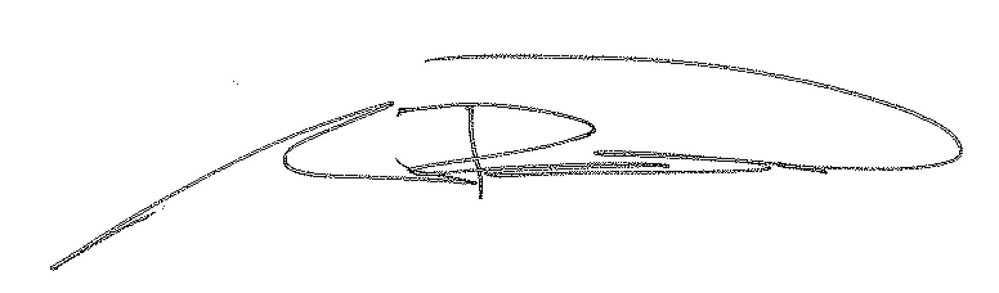

Andrew Buffett

Chair, Pharmacy Association of Nova Scotia

