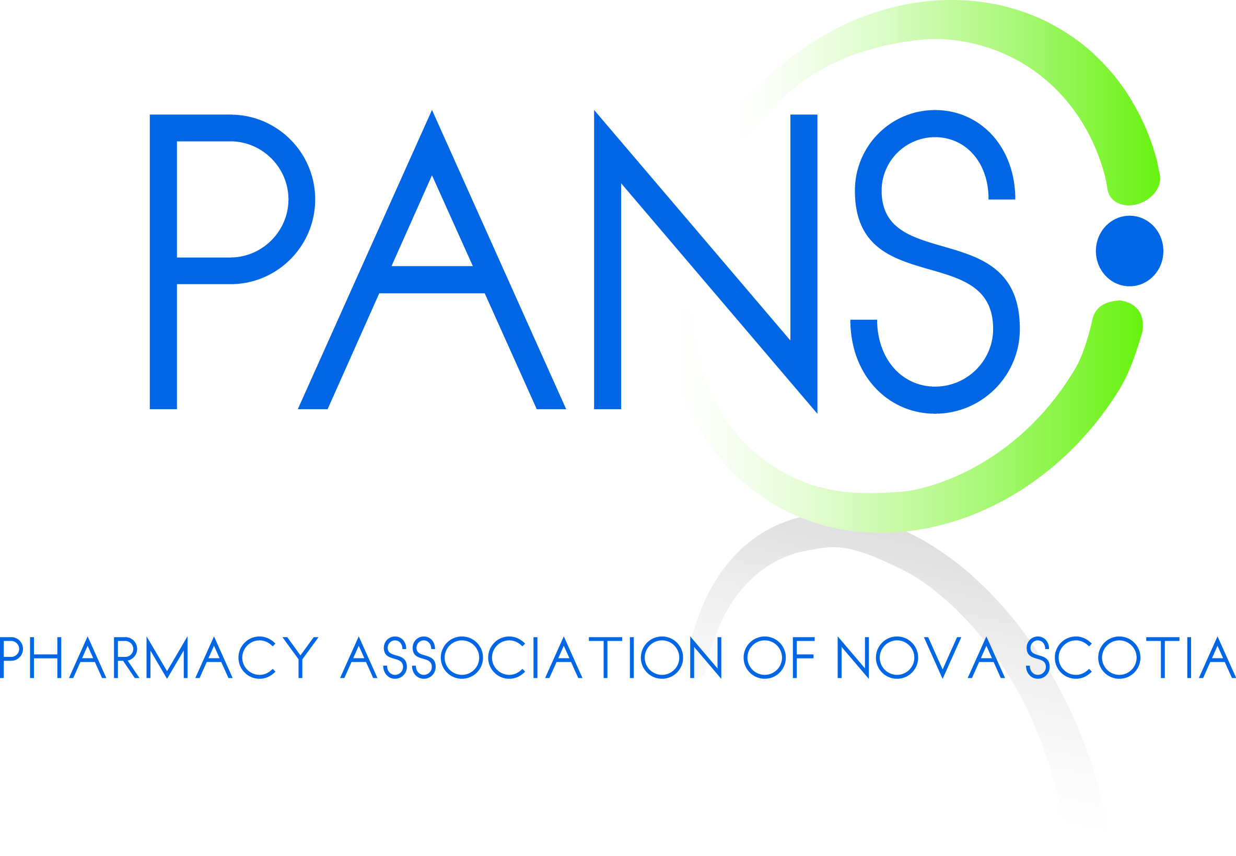
Candidate Meetings September 2013 - Key Messages
The attached talking points are meant to assist you in having meaningful conversations with political candidates in your riding. Our goal is to increase awareness and build relationships so that all parties are familiar with the issues facing pharmacy. As we will be moving into a negotiation shortly after the election, it is critical that notwithstanding which party forms the next government, that they are already familiar with our concerns and ready to move forward quickly with the negotiation. PANS has also sent to each of the 3 main parties, a questionnaire regarding their commitment to pharmacy. Their answers will be published in the Chronicle Herald on September 28th. The questions are attached for your reference.

THERE IS NO SPECIFIC ASK IN THESE MEETINGS, IT IS AN OPPORUNITY TO BUILD RELATIONSHIPS AND LET YOUR CANDIDATES KNOW WHAT PHARAMCY IS DEALING WITH AND ALSO WHAT WE CAN DO TO HELP THEM.

Although NS has not yet followed other provinces such as NB, NL, PEI, ON and AB in reducing generic prices to 25% or less, we know that the Government is expecting to move to this level and will be considering reductions in the future. In addition, although we have one of the most expansive scopes of practice, NS is one of the lowest investors in new services and is failing to take up the opportunity to lower overall costs and improve the healthcare system through appropriate use of resources.

Notwithstanding the huge financial toll that pharmacies have paid over the last few years, pharmacies and pharmacists continue to work to improve care of patients, improve access to care and help stem overall costs so that our healthcare system remains viable for generations to come. A tremendous amount of work has been done in this area over the last few months and it is critical that pharmacists and political candidates become very aware of the solutions that have been offered. These include:

- 6 service proposals submitted by PANS to the Government of NS to introduce (or improve) the following services (to be paid for by Government): Minor Ailment Assessments, Trial Prescription Program, Smoking Cessation Program, Enhanced Medication Review Program, Prescription Renewals and a Mental Health Program;
- 9000 Points of Care Submission (prepared by CACDS, CGPA and CAPDM) which has been publicized broadly and specifically with each provincial government and which has been validated by the Conference Board of Canada. This report makes recommendations that could save the health system in Canada between $8.5 and 11 billion over three years through minor ailments, vaccines, ensuring affordable access to key medications, managing chronic conditions, leveraging the pharmacy distribution model and preventing adverse drug reactions; and
- Submission to the Council of the Federation Health Care Innovation Working Group by CPhA(and supported by all provinces and CACDS) regarding expanding pharmacists scope of practice across the country. This submission is focused on getting pan-Canadian commitment to work together to ensure a “level playing field” in 4 areas of pharmacist practice across the country: minor ailments, immunization services, medication review programs and chronic disease management.

Please familiarize yourself with the above documents and feel free to print and leave copies behind at your meetings. In order to ensure that we know that all potential candidates are being met with and also to track the feedback on these meetings, please email me with a brief summary after any meeting you have. My email is abodnar@pans.ns.ca. If you have any questions prior to your meeting, you can call/email me or Amy at the office.

KEY MESSAGES

- The Government in NS has added approximately 130 drugs to the provincial formulary over the last 2 years and has, at the same time, reduced their total expenditure on prescription drugs by $20M (over 10%) a result of the Fair Drug Prices Act.

- These opportunities to Government have come directly out of the bottom line of pharmacy. Losses generated by the Fair Drug Prices Act (even with higher fees paid) amount to an average of $125,000 per store. Additional losses of at least $40,000 per store have been created through the 6 at 18 initiative implemented April 1st. If the Government makes further changes similar to NB or NL, a further $85,000 will be taken out of EACH pharmacy. This is simply not sustainable.

- Changes to generic pricing have and will continue to have significant consequences. We are seeing drug shortages, increases in costs of single source drugs, exit of manufacturers, reduction in pharmacy wages, lay-offs of pharmacists and pharmacy staff, significant reductions in community support and marketing budgets. Alberta is a perfect example. Many manufacturers have simply refused to supply the province at the mandated 18% and will leave the province.

- Pharmacies can contribute to a more effective healthcare system by providing a range of expanded professional services. These services can not only increase access to the healthcare system for all Nova Scotians, they can help alleviate the financial burden being created by the system. Pharmacists should be utilized and paid as a healthcare provider. Pharmacy has offered many solutions and welcomes the opportunity to work closely with Government to redefine the services provided by pharmacy in this province.

- The proposals submitted by pharmacy (PANS, CPHA, CACDS etc) show the real and significant impact that pharmacy can have on the healthcare system if governments make the bold move to redefine appropriate care such that the patients are provided the right care at the right time by the right provider. We can save the system millions of dollars and ensure sustainability. It just takes a little creative and bold thinking.

- Consider this if the conversation is going well: Why shouldn’t a patient have to go to a pharmacist first if they have one of the enumerated minor ailments? We don’t let patients go directly to an orthopedic surgeon if their knee hurts – we require them to go to a more accessible, less costly option first to see if it can be taken care of. Moving minor ailments out of the physician’s office is exactly the same thing: the right treatment, at the right time by the right provider.

- Before jumping to further pricing changes, the Government must collaborate with pharmacy to review the opportunities being presented. Not only do these opportunities have the potential to save the Government significantly more than further price reductions, they will improve patient care, improve patient access to care and help to ensure the sustainability of the pharmacy sector and overall healthcare system.

